ENBYouthCo-nnect: Summer Springboard

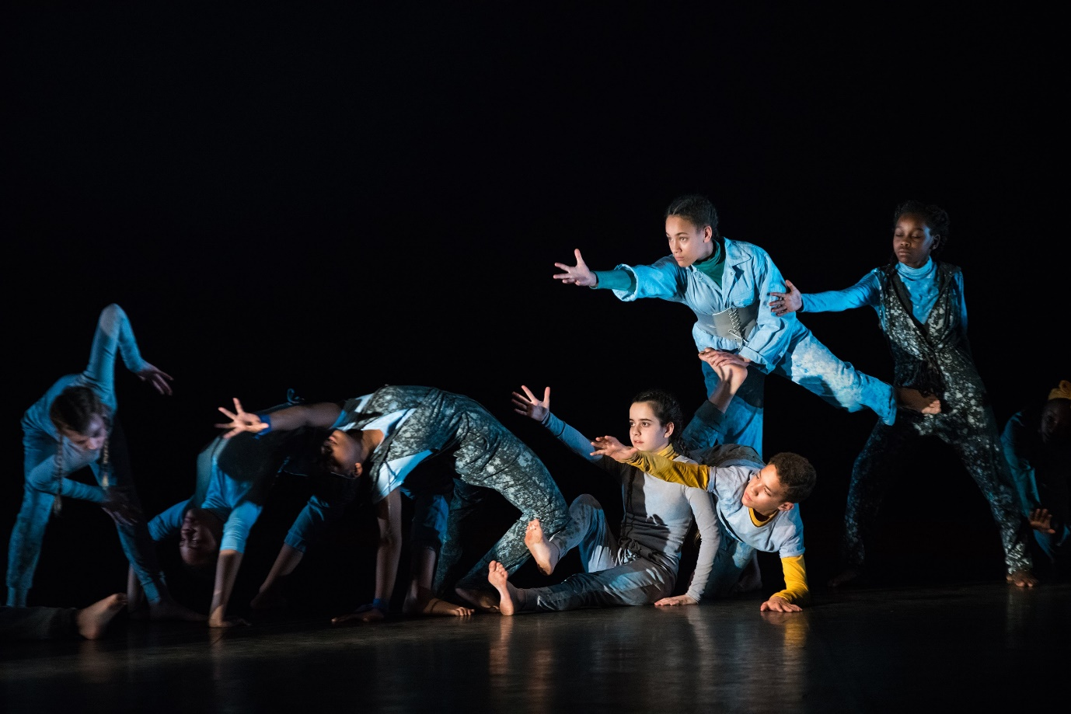

Name: | Age:
Parent/guardian name: | Email:
Emergency contact name: | Emergency contact number:
Statement for participation:
I agree that I am physically fit and have no medical condition that would prevent my safe participation

I have read ENB’s Online Exercise Terms and Conditions and agree to abide by the terms of this disclaimer

I would like to be added to a mailing list to hear about future classes and intensives run by English National Ballet

Please complete and return to engagement@ballet.org.uk.
Closing date Friday 3 July.
Places are limited and allocated on a first come, first served basis.

